Nicholas Sammut

CSC 425 – Mobile Computing

Dr. Mark Allison

InClass Activity 5

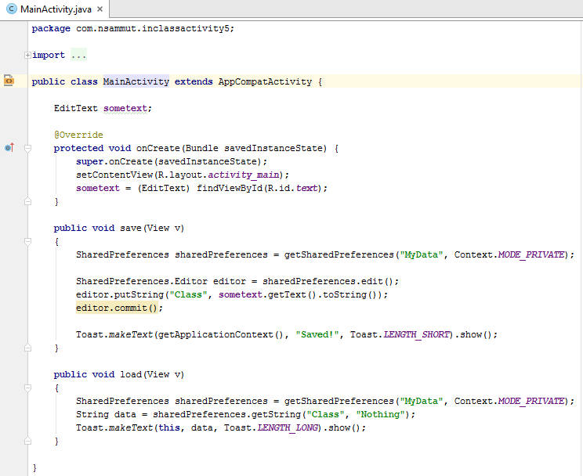­­­­

MainActivity.java

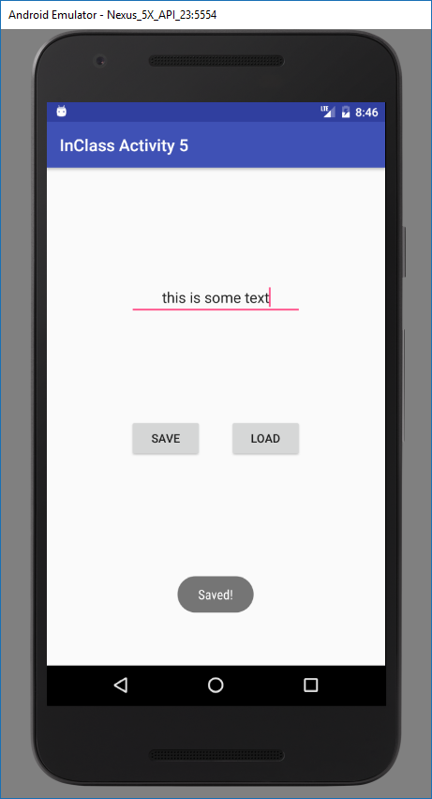­­­­­­­­­­­­­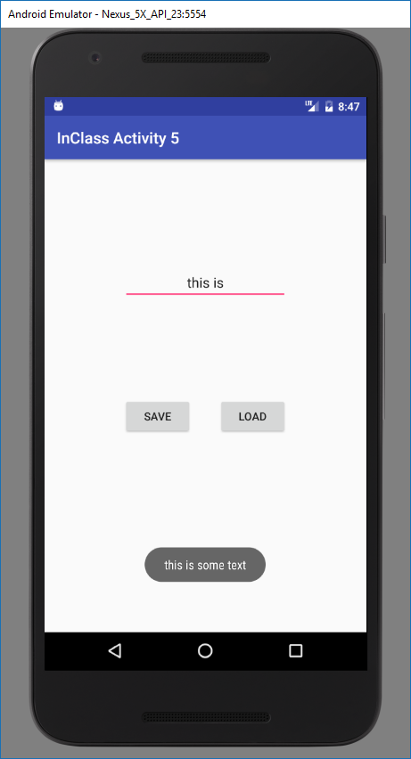

Screenshots of Activity